Kruskal’s algorithm is used in water supply networks. Since Kruskal’s algorithm finds the minimum spanning tree, this becomes really useful when finding the shortest network for water supply.

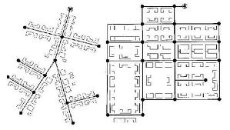

For a water network, lets say we have a goal area. If we divide the area into blocks, we can create edges and vertices. We can start creating edges and order them based on the shortest path. Then using Kruskal’s algorithm, we can create a minimum spanning tree which would give us the shortest path to get water from one path to a final path.

Biblio:

"Kruskal's Algorithm." *Wikipedia*. Wikimedia Foundation, 12 July 2013. Web. 11 Dec. 2013.